
KONERU LAKSHMAIAH EDUCATION FOUNDATION
(Deemed to be University estd, u/s, 3 of the UGC Act, 1956) Green Fields, Guntur District, A.P., India – 522502
Department of Electronics and Communication Engineering
(DST - FIST Sponsored Department)
Course Code: 24SDEC01R Program: B.Tech - ECE
Course Title: ELECTRONIC SYSTEM DESIGN Academic Year: 2025-26- II/IV-II Sem

SKILL EXPERIMENTS RESULTS
STUDENT NAME: Y. Harshavardhan STUDENT ID: 2400040454
EXP. No:1 DATE: 14/07/2025

TITLE OF THE EXPERIMENT: PCB Design Using EasyEDA: Basics and Practical Applications.
AIM: To familiarize yourself with the tools, software, and processes involved in PCB
layout design using EasyEDA.
Components:
• EasyEDA software
• A computer with an internet connection
• A schematic of the Power Supply Design circuit

CIRCUIT DIAGRAM:
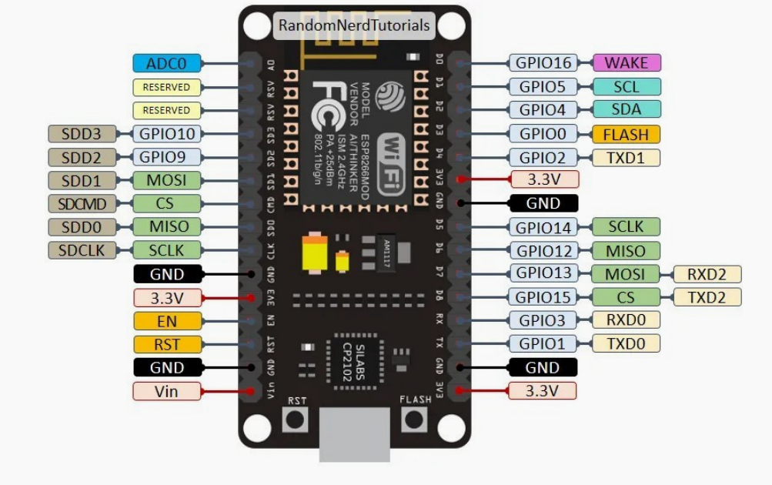
SCHEMATIC:
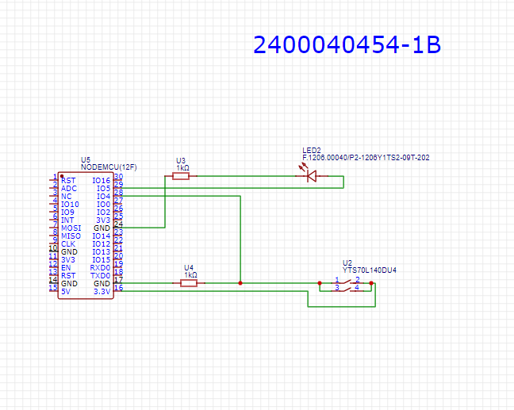

PCB LAYOUT:
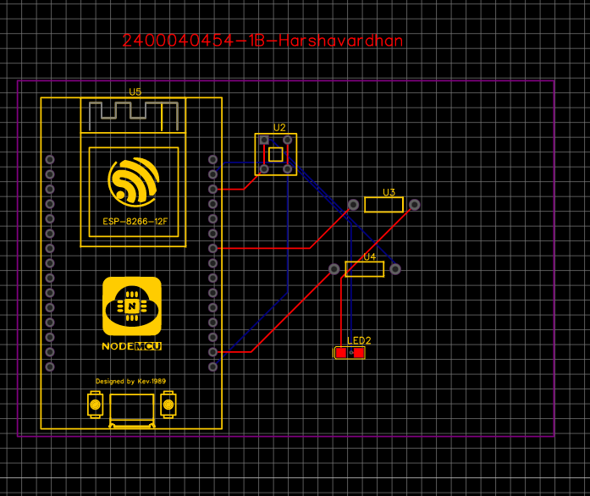
2D VIEW:
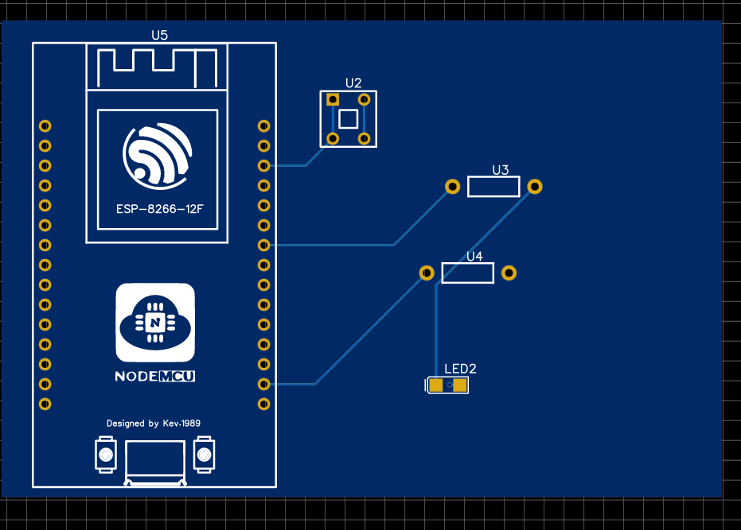
3D VIEW:
